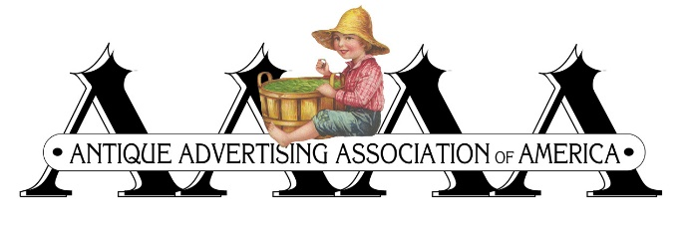
2025 AAAA CONVENTION
Embassy Suites-Dublin (Columbus) Ohio
SCHEDULE OF EVENTS
(Subject to change)
- Hotel check in is 4:00 pm (or later) Hotel Front Desk
- 6:30-9:30 am-Every morning, buffet breakfast served Urban Craft Area
- 5:30-7:00 pm-Every Evening, Complementary Reception (snacks/drinks)

Tuesday, July 15 Pre-convention Room Hopping, Comradery
Wednesday, July 16 AAAA Convention check in, Room Hopping
Thursday, July 17
9:00 am AAAA business meeting - Dublin A
10:00-11:00 AAAA Seminar- “The Lithographs of Rochester” (Ice Screamers Invited)
11:00-12:00 Ice Screamers Seminar - “100 Years of Ice Cream Advertising” (AAAA invited)
12:30 Sandwich buffet lunch - Dublin A
1:30-2:30 AAAA Seminar – “The Artists of Coshocton” (Ice Screamers invited)
3:00-4:00 Ice Cream Social, AAAA invited
4:00-5:00 Ice Screamers business meeting
6:00 Plated dinner served - Dublin A
7:30-? Post-dinner room hopping
Friday, July18 10:00 am-6:00 pm - Public Advertised Room Hopping
Saturday, July 19 9:00 am Convention wrap-up - Lobby/bar area

SEE YOU NEXT YEAR!!! DATES AND LOCATION TO BE ANNOUNCED

